 | 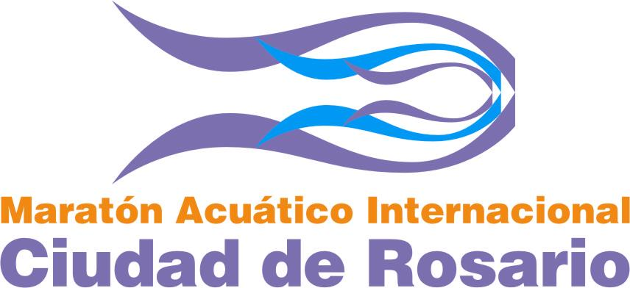 | 

21º MARATON ACUATICO INTERNACIONAL

“CIUDAD DE ROSARIO”

INFORMATION BULLETIN
EVENT:
The 21º Maratón Acuático Internacional “Ciudad de Rosario” will be contested on February 9th, Saturday, 2019. This race will be part of FINA UltraMarathon Swim Series 2019, and will be conducted in accordance with FINA Open Water Swimming Rules.
The event is open to all members of FINA Affiliated Federations. The entry deadline is JANUARY 21st, 2019. All entries, signed by the respective national federation, must be sent to Maratón Acuático Internacional “Ciudad de Rosario” Organizing Committee at the address found on the entry forms.
Entry Form is attached.

COURSE:
There are 15 Kilometers, in a triangle circuit of 1,8 km sited at the front of Balneario “La Florida” and “Rambla Catalunya Beach” in Rosario City. There are approximately 2 hours and 10 minutes of swim, according river’s conditions.
The start and the finish point there are at La Florida Beach (300 mt. down Rosario-Victoria Bridge).

ESCORT BOAT; COACHES OR ASSISTANTS SWIMMERS POSITION:
OC will have safety and judges boats into the triangle circuit and in each of 3 buoys.
Assistant’s swimmers or coaches will be stay at finish pontoon place, where the swimmers will pass each turn (each 15/18 min. approx.).

SAFETY:
Local authorities, the Referee, the OC, and Meet Management have the authority to postpone or end the event for safety reasons.

PRIZE MONEY:
The total value of the prize money available is of U$S 10.000.- (ten thousands U.S. dollars). Will be paid without exceptions on February, Monday 10^{th,} (11AM).

LODGING:
According FINA OWSGP Rules, the Organizing Committee will provide accommodation and board expenses for five (5) days, and five (5) nights (from Tuesday 5th (night) to Sunday 10th (noon) (included)) for:
• At least twenty (20) swimmers. In this number shall be included: At least one (1) swimmer and one (1) coach from each participating Federation. The coach has to be appointed by the National Federation.
Under the large number of swimmers and countries, the acceptance does not mean totally free accommodation. Please check your lodging situation with the organizing committee.
Swimmers and coaches will share twin or triple rooms;
Hotel services (laundry, room service, local and international telephone calls, bar, etc.-) will be at user’s own cost.

EVENT SCHEDULE AND RACE MEETINGS:
All swimmers must attend all required officials meetings and activities (interviews, promotional sprint, presentations, shows and others) until theirs departs on February 10th.
Complete event schedule will be provided to participants.

TRANSFER TO BUENOS AIRES AIRPORT (300KM):
OC can offer this service for foreigners swimmers and coaches, from the Hotel at Rosario city to Buenos Aires International Airport (Ezeiza) (300 km). For this, the interested must send the flight information (flight number, airline, depart time), at OC before February 21th.
The cost of this service, it’s USD 30 each person and will be payed to the driver. Only with reservations.

MEET DIRECTOR: Mr. CRISTIAN FREDES (phone cell +54 9 341 3040701)

OC request your National Flag to be used at the finish point. To be returned after the race.
If being under age on the first day of the Championships I am entering, I wish my parent or guardian to sign this statement on my behalf.

Date:

Signature:

